New Information is in Blue Text
Event Name | Caldor Fire: 08242021-163
Date | 09/08/2021 700
Report Number | 21
Duty Officer – 775-687-0498: Lori Degristina
Current Situation
Governor Sisolak has signed a Declaration of Emergency and the Douglas County Board of Commissioners has declared a State of Emergency in response to the Caldor Fire. As of 0700 the fire has burned 217,569 acres and is 50% contained. Expected 100% containment date is September 27, 2021. The Evacuation orders in areas of El Dorado County, California have been downgraded to evacuation warnings or lifted. Mandatory evacuations in Douglas County, NV have been downgraded to evacuation warnings for Upper Kingsbury (North and South), Central Kingsbury, and Lower Kingsbury. South Lake Tahoe is still closed to non-essential travel. All residents and workers for Nevada have been allowed to repopulate the Kingsbury and Stateline area. All road restrictions have been lifted in the Nevada region and repopulation efforts have begun.
There is a potential wind event starting Friday afternoon and lasting for the weekend.
ESF 1: Transportation |  |  | Duty Officer: 775-888-7645
All road restrictions have been lifted. NDOT will be keeping personnel on standby for a contingency of fire activity until Friday, September 10, 2021. California authorities are conducting ID checks.

ESF 4: Fire |  |  | Duty Officer: 775-684-2560
Nevada Division of Forestry has personnel, equipment and crews supporting Cal Fire on the Caldor Fire. ESF 4 has moved to remote contact.

ESF 6: Mass Care
ESF 6 is standing by to react to the outflow of evacuees as the repopulation effort has begun.

As of 0900 on 9/8/2021, there is only one Nevada shelter open for the Caldor fire incident: The Reno-Sparks Convention Center. The population of this shelter is steadily declining.

Red Cross Managed Shelter Updates as of midnight on 9/6/21:
Congregate Shelters
Total Congregate Shelters in NSS: 1 (-1) from yesterday
Total Congregate Shelter Population: 49 (-53) from yesterday

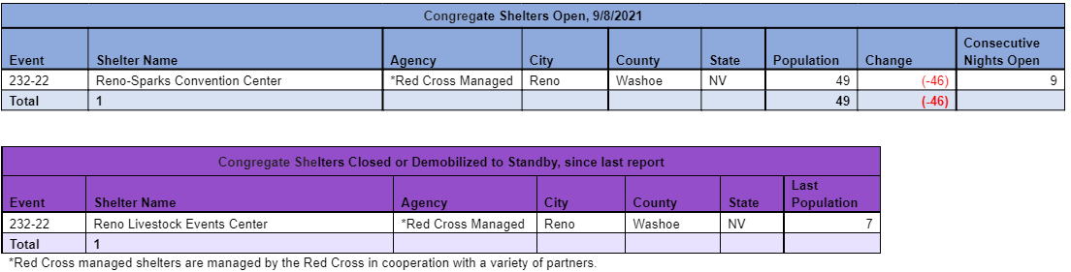

Mass Care Feeding
With support from community partners, a fixed feeding site has been established to provide feeding at all congregate shelter locations.
Meals Served: 226 period / 7,933 to-date
Snacks Served: 313 period / 4,874 to-date

Mass Care Distribution of Emergency Supplies (DES)
Comfort Kits Distributed in Shelters: 0 period / 406 to-date

ESF 8: Public Health |  |  | Duty Officer: 775-684-5920
Barton Memorial Hospital reopened with limited services, including Emergency Department, advanced life support services, acute care, laboratory and emergency imaging. Barton will continue to reopen services and medical offices as soon as possible. Refer to BartonHealth.org for more details. Barton Memorial Hospital is keeping capacity open for repopulation related needs.
Providing COVID tests to shelters and licensure waivers to healthcare workers coming into the state.

ESF 10: Hazmat |  | Rebecca Bodnar: 406-270-6000
ESF 10 has moved to remote contact.

ESF 11: Agriculture |  | William Striejewske: 775-846-1165
ESF 11 has moved to remote contact.

ESF 12: Energy |  |  | Lorayn Walser: 775-230-9851
ESF-12 remains in contact with fuel suppliers and utilities, especially as re-population planning moves forward. Fuel inventory is currently strong. Southwest Gas proactively turned off meters for safety reasons in 3 sections of previously isolated and evacuated areas in South Lake Tahoe, CA. Currently 585 customers presently without natural gas service on the California side of Lake Tahoe. Southwest Gas has begun to re-gas the pipeline to one currently shut off section and are prepared to re-gas the other two zones when Cal Fire says it's safe to do so. Southwest Gas is also planning for repopulation and restoring service.

NV Energy continues to undertake proactive measures to prevent line and power loss, including pole wrapping on the Muller 1295 line along Foothill Road, removing vegetation along Foothill Road under lines to create a fire break, and continuing working in the Foothill Road and Kingsbury area to remove vegetation. As of 1900 on 09/03/21, the fire was 1.5 miles from NV Energy infrastructure, specifically the Kingsbury 111 line which has no impact to NV Energy customers. No NV Energy customers in Douglas County are without power and no PSOM events are planned.

ESF 12 has moved to remote contact.

ESF 13: Law Enforcement |  |  | Capt. Bill Murwin: 775-720-8518
Continue to monitor traffic control points and are actively patrolling the areas.

ESF 15: Public Information |  |  | Gail Powell: 775-434-4795
Continuing to coordinate and disseminate information regarding safe repopulation of evacuees. Working on publishing stories on community individuals/businesses that supported first responders and evacuees. Campaign to highlight ESF partners housed in the SEOC, their role supporting the incident and the importance of their work

Please see the below for donation efforts regarding various agencies:
El Dorado Community Foundation: https://edcf.fcsuite.com/erp/donate/create?funit_id=1792
The American Red Cross: https://www.redcross.org/donate/cm/abc10-pub.html/.
Placer Food Bank: https://donate.placerfoodbank.org/for/pfb?_ga=2.168769441.1692671111.1585586084- 667740226.1583304010
Food Bank of Northern Nevada: https://give.fbnn.org/for/zcjkyj/
Project Camp: https://projectcamp.co/
El Dorado County Animal Services: https://www.edcgov.us/Government/AnimalServices/pages/pet_aid_fund.aspx

Joint Information System has been activated and members have been given assignments. Coordination with CalOES, CalFire and county PIO’s on the California side. Questions for the JIC can be forwarded to 775-687-0395 or communicationrelationspio@gmail.com.

ESF 16: Nevada National Guard |  |  | JOC: 775-887-7200
All Nevada National Guard personnel have been demobilized.

